Exploring Where Good Ideas Come From?
ILUSTRATION OF THE SORTS OF ARTICLES WE CAN INCLUDE IN CREATIVE ACADEMIC MAGAZINE FORMED AROUND THE CONTENT 0F THE COMMUNITY - PLEASE ADD TO OR EDIT THE COMMENTARY

One of the activities in Week 7 was to watch and reflect on the RSA Animate video of Steven Johnson's talk on where good ideas come from. The talk is posted on YouTube
https://www.youtube.com/watch?v=NugRZGDbPFU and it has received over 4million hits.
Steven talks about the environments that encourage creative ideas. Environments that enable half formed ideas to exist for a long period of time in a person's mind before colliding with another half formed idea that fuse to form something that is now complete and different to what has existed before. The following responses from student participants reveal their reflections on the ideas that were share.
Activity week 7: 2-ILO2- Watch the following clip and then reflect on your ideas with peers

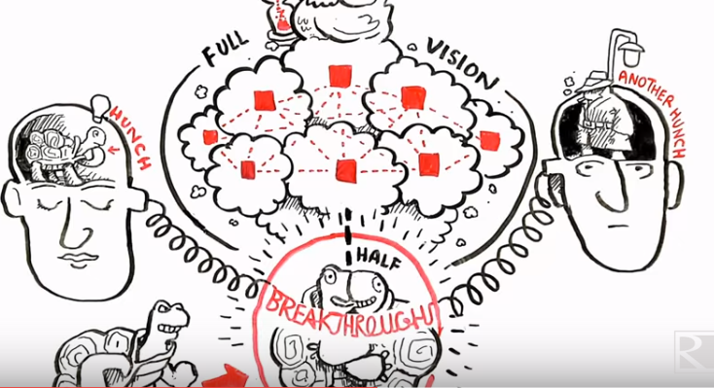

The 4 minute animated video encouraged students to think about where good ideas came from and where their ideas came from and how they formed from combining them with other ideas. But they also thought about the internet of ideas and the potential challenges of easy access to ideas. One thing is certain the animated talk inspired some students to think in ways they had not thought before.

Rafaela Tz Reflection on Steven Johnson's video.."WHERE GOOD IDEAS COME FROM" was one of the best videos I have ever seen. Inspiring, understandable, amazingly designed and sketched..

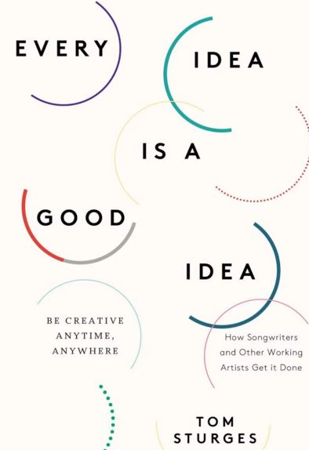
Anna Kotsani I agree with Steven's opinion that good ideas come after a long time and work. We take ideas from other people, from people we've learned from, even from people we run into in the coffee shop, and we stitch them together into new forms and we create something new. We gain knowledge of our environment which is chaotic, where ideas are likely to come together. Thus people are energetic and ready to create new things. Although we need time to create new ideas, many times we become more creative and our ideas are formed by connectivity as well..In our society , we combine different ideas from media , from our communication with others and when we participate in projects. If someone working on something for a long time is likely to find interesting ideas and then to search about usual rates of creativity and innovation!! So , let's create good ideas !!! Have you ever been more creative ? I have been when I started a lifelong programme about art ! I was wondering how i could be more creative with full of imagination!! We must believe that abilities, intelligence and talents are developed leading to the creation of new and better ideas!!! ﻿

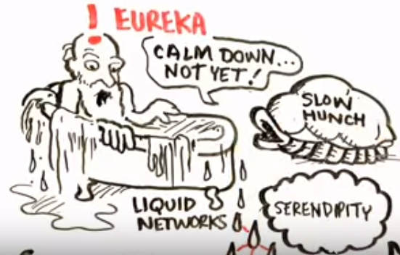
Kostas Papas A few ideas about Steven Johnson's presentation. One basic opinion that's expressed on the video, is that good ideas, ideas that are innovative, or even groundbreaking are a result of a long process, that could take even years to come to that form. I partially agree with that, because I think that it is possible and probable for someone to have a "eureka" time and so to invent something, or think something extraordinary, that came up subconsciously. Also, [new] ideas usually [produced] by the collision, interaction, comparison with previous ideas. That happens, because every individual has a background of knowledge, experience, which along with the influence of the working or educational environment form the new idea. Furthermore, through internet and social media, everyone, in this modern age of information and connectivity, can have an idea that can be incomplete, or false, or in an early stage and he/she has unlimited opportunities to find new ideas, or complete his/her own by finding and using with any way other people's ideas from all over the work.

Commentary: Another student built on the perception that we can become lazy with other people's ideas and suggested that we use our creativity to do something new with other people's ideas. By connecting and combining ideas we distil them into a new idea.

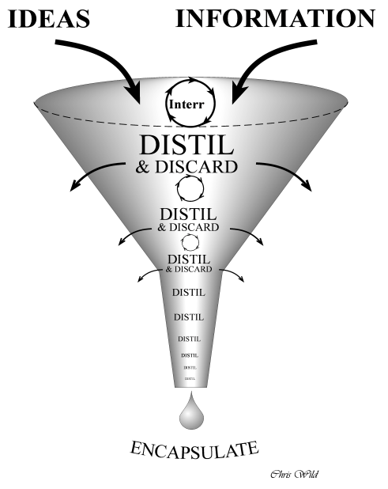
Nikos Mouratoglou "Where good ideas come from?" Hmmm, I must say that this is a pretty much difficult question to answer as there in not a clear suggestion which would include the multidimensional term of creativity. Correspondingly, the video from Steven Johnson is based on the environmental perspective, a standpoint which delimits creativity in such a way that it's easier to be approached. I agree with the statements suggested in the video, as the communicative channels increase knowledge diffusion and therefore multiple opinions, ideas, information and interactions are easily accessible and available. As a consequence individuals face a larger exposure to inflows, something that of course broadens their cognitive horizons, but also provides them with the opportunity to reflect on their experiences, challenge their prior knowledge and perhaps lead them to new ideas. In my opinion, technological evolvement supports the whole procedure by increasing the external impulses, but the problem is that creativity is not just interwoven with those external impulses. By this, I mean that an individual should have developed such skills that could take advantage of the inflows and transform them into creative ideas. An idea, is just an idea, but a creative idea is a distilled idea. In other words, creative ideas are results of thinking, combining, accepting, rejecting, reflecting, editing and in general managing information-events-ideas. This differentiation is the key in which education should lay more emphasis, always according to my opinion. P.S. In this case, action research can be a valuable tool, as the spiral form provides this distilling dimension, in which the participants are being involved in a Tug-of-War process.

Commentary: Another reflection was that our ideas are simply building on the ideas of people who have thought these sorts of things long before us and the idea that we are standing on the shoulder of giants and perhaps ordinary people as well. This perhaps was a sort of collaboration and co-creation across time which complements the more normal collaborative actives we undertake in groups, teams and communities - such as this one.

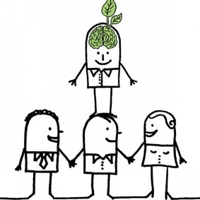
Elisavet Sofia Katsanou I agree with Steven Johnson that good ideas usually come after a long time and work. I also completely agree that connectivity between people and ideas is very important for creativity. The video reminded me of Isaac Newton's famous quote ''If I have seen further it is by standing on the shoulders of giants'. In relation to that video, I interpret the ''the shoulders of giants'' as the prior work done in a subject by an individual, or the study of the work of others, which allows him/her to go a step further. Even the failed attempts can be used as a base for a person to move further.

About the importance of connectivity, it reminds me of a college professor who used to tell us about the importance of group work that it defies math logic, because if we have ten people, by whom each one can offer one, and we put them together in a group, they won't offer ten but eleven. I think that is similar with what is happening when some different ideas are combined and complete each other, and the final result is much greater than the sum of these two individual ideas. Connecting different ideas has definitely become easier in our days, as so many people have access to so many sources of information. Of course, in order for these ideas to be connected, one must look at them examining with what they could be connected. I have also noticed about myself, that when I am working on something for a long time, I can find interesting ideas that could connect with that in places that are seemingly unrelated with that subject.﻿

Commentary: But students also expressed concern that the internet was making it too easy to encounter ideas and we have to be wary of being turned into uncritical consumers who are not prepared to do the hard work of thinking about and playing with ideas.

Rafaela Tz I agree with the ideas expressed. I just have one doubt..I think that social media, like facebook, do get us distracted a lot. Plus, by getting everything ready, seeing lots of ideas, reading everything other's post, gets us a little bit "lazy". Everything is out there, easy for us to reach and see, so we don't have to think, we just receive and reproduce. Ok, we are involved into the combination and construction phase of the ideas, but it only happens in a small percentage. [But] How is that helping us evolve and develop our creativity?

Panagiotis Kesisoglou ......... As far as the Internet concerns, it is my opinion that many times it fades us away from the purpose to share ideas and transforms us into passive creatures. All the devices that have a screen provoke this and effect our brains due to the light and the bright colours and cause our brain to be underactive but it is a necessity nowadays. It is our duty to try and link the traditional ways of writing down our thoughts and observations with the modern ways of communication. We should keep the measure in what we do which is excellent as the ancient Greek maintained.

Katerina Kliani ...... Despite the fact that inspiration can come out of the closet in a single moment, I want to underline that a lot of hours of investigation, work and interaction with other people and the environment are required [to produce a good idea]. People need each other, so that new ideas could be shaped through different information, multiple opinions and experiences. In my view, technological evolvement can support the procedure of creating new ideas if it is used properly. What I mean is that the outcomes are positive if technology does not distract people excessively and if people are actively involved and do not get everything ready. ﻿

Sources
Johnson, S . ( ) Where good ideas come from RSA Animate
https://www.youtube.com/watch?v=NugRZGDbPFU
There is also a longer TED Talk https://www.youtube.com/watch?v=0af00UcTO-c

