Making Porridge 2.0: Turning a daily habit into an opportunity for creative self-expression and a gift to the world
Chris Tomlinson interviewed by Norman Jackson

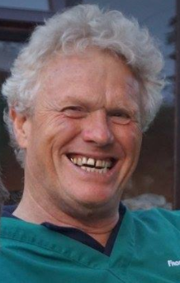
Starting my day with a bowl porridge has never really appealed to me, especially as a way of starting my day, but after visiting Chris Tomlinson’s, a day without porridge Instagram page¹, I can better appreciate the beauty and meanings in a bowl of porridge. Chris, who just happens to be my brother in law, is a busy Norfolk vet and chatting to him on skype I discovered he has been an avid consumer of porridge for many years: a breakfast bowl sets him up for the day especially if he adds a bit of fruit to it. But what had been a daily routine was transformed 8 months ago, when a member of the family suggested he should be more adventurous with his porridge.

Chris picks up the story…

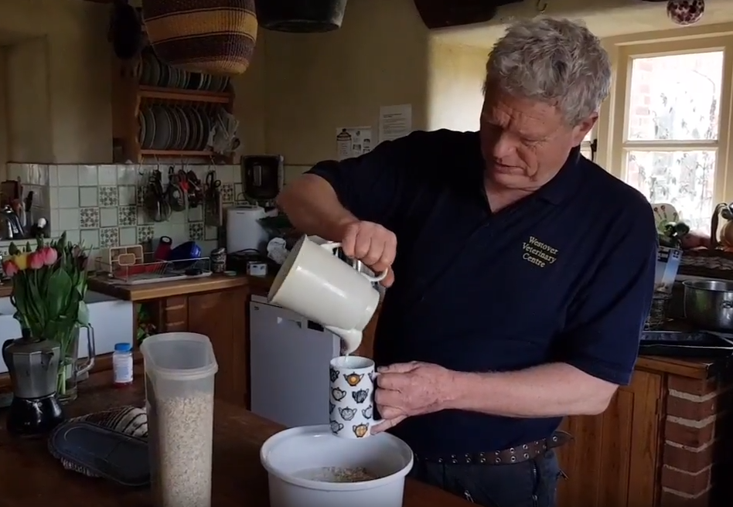
I’ve been eating porridge every day for three or four years, I can't remember when it all started. Now porridge by itself is not very appealing so you try out different things to put on the porridge, you can have syrup, you can have jam, you can have fruit, you can have frozen fruit, you can have dried fruit. As I chopped up the fruit I started to make patterns which were quite satisfying to make. So I developed the habit of putting different things on my porridge. Then last summer my daughter-in-law said, “You should be posting this on Instagram”, partly tongue in cheek I think just to see what would happen.

So she set me up an Instagram account and I started experimenting, arranging different things on my porridge and thinking about different aspects of life at the same time. It's just a sort of- whatever comes to my mind, I pop on my porridge for that day.
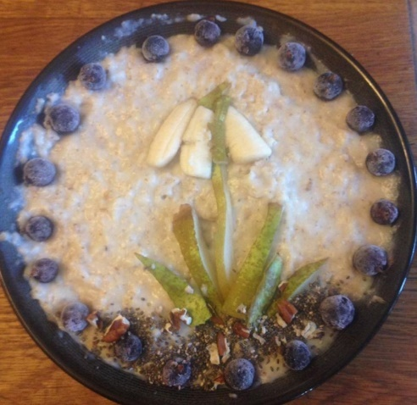
The other day we went and saw the snowdrops at Walsingham Abbey so I did a design of the snowdrop.
Norman: I really liked that one
Chris: Around Christmas time I did some reflections on the nativity story with different scenes from it. There was a cow, there was a sheep, there was a duck, there was a camel (left above) there were some wise men (middle above) there was a shepherd and nativity scenes.

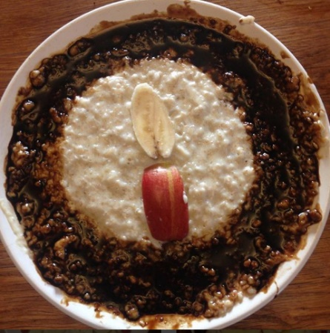
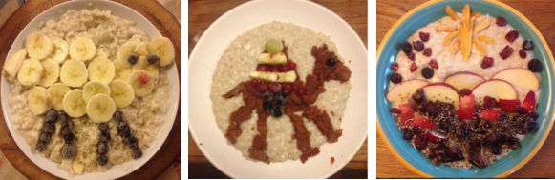
Another one I did was to commemorate holocaust day with a candle and a circle of treacle.
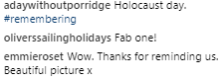

Norman: So making a picture or design on your porridge is fairy spontaneous, it's something that you only begin to think about as you are making your porridge.
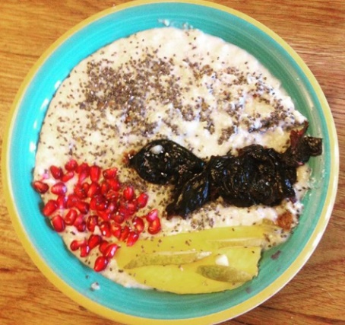
Chris: Yes, I would say so. Very rarely do I spend a lot of time thinking about it. I normally get the porridge in the bowl. It's cooked in the microwave, it takes 15 minutes to cook in the microwave. I'm getting the kids up and ready. I'm cooking their breakfast, and then I get the porridge in the bowl, it's all being cooked in the microwave and stood to just to make it more smooth, and then I get- what fruits are available and think “What shall I do today?” Yesterday we went to see the seals at Horsey Gap. I thought, “Well, I’ll put a seal on made out of prunes.” It wasn't the best seal but it was the fact I’d tried that mattered.
Other times I think, “Can’t think of anything, I’ll just do a pattern.” I’ll do a circular pattern of some sort and it just whatever comes to mind with what I have ready to hand.
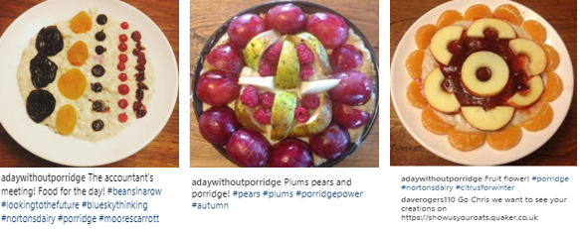
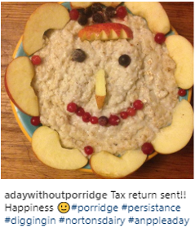
Norman: It sounds as if there is a real commitment that every day you’ll have to do something, it's not an option not- to have a design on your bowl of porridge at the end of the making process.
Chris: It's kind of fun to be feeding pictures of my porridge to people on Facebook and Instagram, “This is my porridge for today,” You get the feedback from people and it tells you it brings a smile on people's faces and they enjoy seeing what I have done with my porridge, it's like a little feature in their life.

Norman: That explains your motivations for sustaining your commitment. You challenge yourself to come up with a design but you also do it for other people.
Chris: Yes, definitely, if it didn't engage with other people, I don't think I’d have the same energy to be doing a bowl of porridge with some pattern on it every day, I’d just throw it in, and then eat it. Because people enjoy it, I enjoy it doing it with them really. It's a shared experience. I'm a great believer that often art should be a creative environment between the artist and the people. There should be a kind of feedback or rapport going on, which I feel happens with my veterinary work as well.
It's an ongoing conversation between myself and my clients and I find that with my Facebook friends as well. This conversation and somebody's, "Oh, I really like that one" or, "That was a bit rubbish." You just enjoy having this conversation going on. Some people said, "I really liked your bowl of porridge because most things on Facebook really make me sad but this makes me happy." You think, "Nice to be able to put a little- something into people's lives," as simple as the bowl of porridge with a pattern on the front.
Typical Facebook Comments
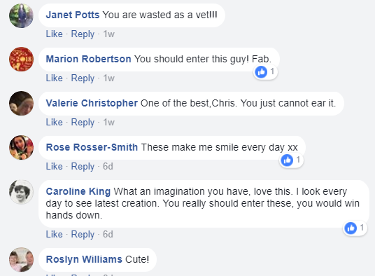

Norman: Now you are bringing in the fact that technology enables you to share and communicate your little creation. Without that technology, you could not do it?
Chris: Exactly. Before things like Facebook and Instagram you were very limited. You wouldn’t do it. You would be much more limited and only the immediate family would see it and they would say - “Well, that's all right” and you’d think “well why should I other”
Also it's nice to let people to see another side of me. I’ve got quite a few clients who like to see my post and my Facebook friends and family and, “what I’ve done with my porridge today” gives them a little fun in the office at work.
Chris: Have you drawn on the feedback in anyway? Have people’s comments inspired new designs? Have you got ideas from people who've been commenting on your porridges?
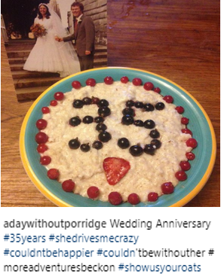
Chris: No, but I think what I’ve realised is people like quite clear lines and that’s what I find on ‘porridge art’. You've to have quite clear lines. If it’s all blurry, it doesn't stand out. People can't understand it. While if you have quite definite patterns, then people can see it and it registers with them.
Norman: What is porridge art?
Chris: What is porridge art? Porridge art is putting up a pattern on top of your porridge which engages with people either because they think it’s pretty or it reminds them of something or it gives them a thought. I put a 35 for my wedding anniversary last week, and then on valentines, it was a heart. It was just- playing around with ideas, visual ideas I suppose.
Norman: When you say porridge art, does that mean there’s a community of porridge artists?
Chris: There are other people who do patterns on their porridge as well and I found that on Instagram, which is kind of fun. So I follow a few people who do patterns on their porridge every day as well as I do.
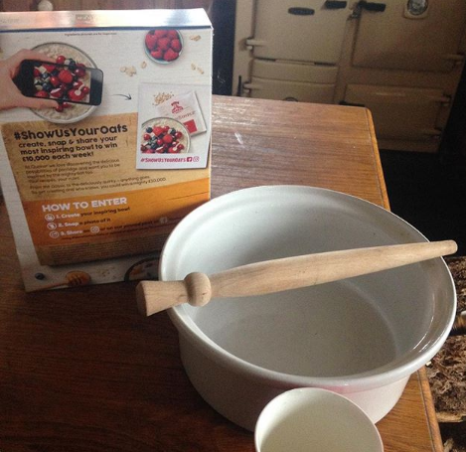
Norman: So there, again, the medium, the technology helps you connect to a community of people who think and act like you do with your porridge.
Chris: Exactly. The interesting thing is Quaker Oats have spotted this and done a competition called “Show us your oats” for people to send in photos of what they put on their porridge and how it looks pretty. I've had a go in it, but it really hasn't affected much what I do because I enjoy doing it. Though there’s a £10,000 prize, that doesn't really alter the way I do my decoration on the porridge.
Norman: You've been doing this for about 8 months and you’ve now made over 200 bowls of decorated porridge. So what have you learnt from this whole process about yourself?
Chris: What I’ve learnt about myself? That I can be more creative than I realize and that people enjoy seeing it. So that’s essentially -- people like seeing another part of me. If you're prepared to put it out there, you do develop and improve techniques with time. It’s amazing what you can put on a bowl of porridge to tell a story, maybe one snap shot over two or three days. It’s just fun watching how the story unfolds.
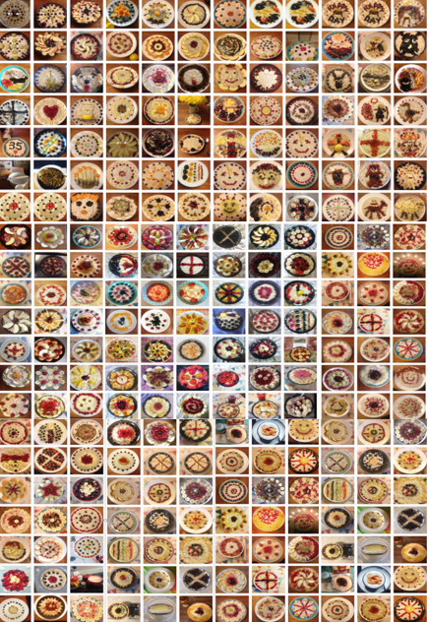
Norman: One final question, in the context of your experience of making porridge art, what does creativity mean to you?
Creativity is expressing something about yourself in your daily life.. so its not doing something that everybody else does in the same way as everyone else does it, but doing something which shows something of your personality.

Chris’ magnificent curated collection of 216 Instagram porridge posts (25/02/18)

Making porridge - a project for personal growth
Anthropologist Tim Ingold offers two perspectives on the idea and process of making namely³: making as a project ‘we start with an idea in mind, of what we want to achieve, and with a supply of the raw material needed to achieve it. And it is to finish at the moment when the material has taken on the intended form’, or making….as a process of growth’, ‘the maker from the outset [is] a participant .. amongst a world of active materials. These materials are what he has to work with, and in the process of making he ‘joins forces’ with them, bringing them together or splitting them apart, synthesising and distilling, in anticipation of what might emerge.’
The way Chris talks about his making, suggests that both of these ideas are in play. Clearly, the repetition of making a certain thing (a bowl of porridge containing a picture of design), and communicating the results via Instagram and facebook is a personal project. There is a daily commitment to the process of making, and in his mind as he gets up every day, there is the idea that he will make something with his porridge but when he starts his daily routine that something has not yet been defined. But once he begins to make his porridge he enters a world in which his imagination can grow as he starts to engage with the materials available to him. These include the raw ingredients of oats, milk, fruit and other toppings he uses, and the props (like photographs, flowers, candles, ballons) he displays near his porridge. But they also include the events, situations, incidents and circumstances in his life and the relationships he has with people and animals, his work, his beliefs and many other things in his life.
“and then I get- what fruits are available and think “What shall I do today?” Yesterday we went to see the seals at Horsey Gap. I thought, “Well, I’ll put a seal on made out of prunes.” It wasn't the best seal but it was the fact I’d tried that mattered.
Other times I think, “Can’t think of anything, I’ll just do a pattern.” I’ll do a circular pattern of some sort and it just whatever comes to mind with what I have ready to hand.”
Using anthropologist Tim Ingold’s words, ‘even if the maker has a form in mind, it is not this form that creates the work. It is the engagement with materials….’ In Chris’ case the materials of his life, wonderfully illustrated in these two Facebook posts on March 2nd include incidents and experiences that constitute his everyday doings.
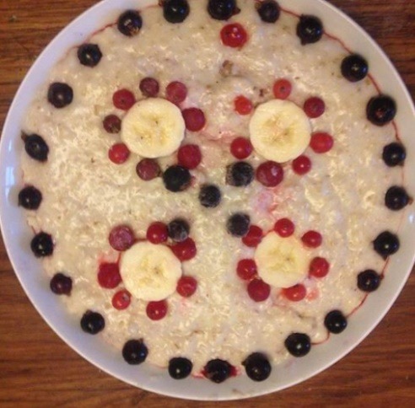
Facebook: March 2nd This was yesterday trying to dig myself out of a snowdrift at Hainford!

Porridge art he posted on March 2nd. ‘Gratitude to 4 wheel drive getting me to work today!’

Technology as a material
Chris makes good use of technology – mobile phone and social media like Instagram and Facebook, in the curation and sharing of his making. As an active creator of artistic artefacts he makes the point that art as a phenomenon involves interaction between the ‘maker’ of the art and the person who is receiving, perceiving and responding to the artefact. Social media facilitates this interaction and allows for conversation and the sharing of meanings between the art maker and giver and the receiver. Without this mediating tool how could Chris ever know what people think of what he has made. The appreciative feedback he receives, especially when people say it puts a smile on their face, is the extrinsic motivation he needs to sustain his commitment and build his confidence to push himself a little further. It must also put a smile on Chris’ face as well.. when he says ‘it’s fun’, he means it.

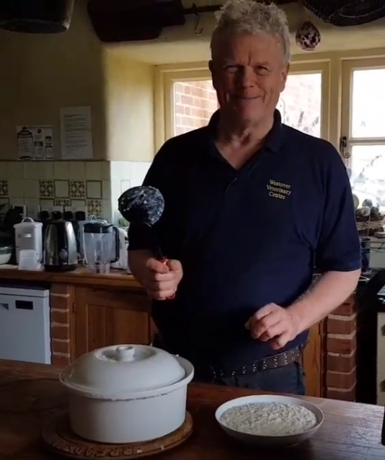
Chris Making Porridge
Chris is my brother in law and a few weeks after I interviewed him, we had to visit him on a family related matter, so I took the opportunity to make a video recording of him making his porridge.
He is a natural presenter and I joked that he could do a TV series called ‘Chris in the Kitchen. The 8min video reveals how he goes about making his porridge and it shows how he works with the materials.

https://www.youtube.com/watch?v=ytFtrgZT9qU&t=1s

Towards an ecological view of making porridge with meaning
Chris provides a lovely illustration of how, with a bit of effort and commitment, we can transform a daily routine like making a bowl of porridge requiring little imagination into a vehicle for imagination and creativity. The porridge has become his medium for self-expression and the pictures and designs he creates cause him to reflect on his own beliefs, people, events and other circumstances in his life. In this way he gives a humble bowl of porridge personal meaning.
Making is connecting because you have to connect things together (materials, ideas, or both) to make something new; Making is connecting because acts of creativity usually involve, at some point, a social dimension and connect us with other people; And making is connecting because through making things and sharing them in the world, we increase our engagement and connection with our social and physical environments.’^{4:2}
These propositions are all relevant and valid for Chris’ story. His porridge art connects materials, ideas, beliefs and life events that mean something to him to enhance the meaning of an ordinary bowl of porridge. By photographing and posting his artefact he shares his designs and meaning making with the world via Instagram and facebook and friends and family who follow him are able to enjoy the fruits of his work and give him feedback on what he has produced. Knowing that others appreciate his efforts is a significant factor in motivating him to sustain his creative project. While the topics he chooses to represent in his porridge art clearly show that he is using the opportunity to engage with his own life in a novel, playful and sometimes reflective way.
After watching the video of Chris making porridge on Mother’s Day, Joy Witton offered the following perspective,

It's more about gift-giving than representing or reproducing I think……..- this gift giving imagines the mothers who are the recipients of the gift, and - as Chris says - honours, remembers and celebrates mothers and mothers' love - the original gift givers (of life, food and love). His creativity produces a gift which is a return of that original gift….. he ‘paints’ with porridge because it is such a right symbol of nourishment! (Wonderful porridge, made with raw milk which lasts you through an entire morning - I wanted to eat some!).
Tim Ingold’s idea that that an artefact is both the product of our thinking and skill, and the materials themselves influence our thinking as we work with them and discover their constraints and possibilities, is an ecological way of visualizing the creative process. This way of understanding making is consistent with Carl Rogers⁵ conception of a creative process ‘the emergence in action of a novel relational product growing out of the uniqueness of the individual on the one hand, and the materials, events, or circumstances of their life’.

The explanation given by Chris of what being creative meant to him aligns well to this ecological concept of creativity as being an act of self-expression that is a characteristic of the uniqueness in everyone. In his own words, ‘creativity is expressing something about yourself in your daily life.. so its not doing something that everybody else does in the same way as everyone else does it, but doing something which shows something of your personality.’ In making his designs he draws on the materials in his cupboard, fridge and freezer, he draws in recent or soon to be events in his life to provide the subjects for his imagination and designs which are meaningful to him and to the people who know him.

Another thing that struck me was that in making this daily commitment Chris was, in a small way, documenting moments and events in his life. I have never thought of the idea of a ‘porridge diary’ before but that’s what his curated collection is. Thanks to the curatorial capacity of Instagram, Chris has created a diary in porridge designs, pictures and captions. Having collated his designs it also struck me that his collection makes a wonderful visual artefact with aesthetic appeal in its own right.
Chris’ story also illustrates how technology helps us share our creations with others by posting pictures of what we have made on social media platforms such Instagram, Facebook and Twitter. In this way social media supports a culture of gift giving. Chris makes the point that art involves an interaction between the ‘maker’ of the art and the person who is receiving and perceiving the art. Social media facilitates this interaction and allows for conversation and the sharing of meanings between the art maker and giver and the receiver. Without this mediating tool how could Chris ever know what people think of what he has made. The appreciative feedback he receives, especially when people say it puts a smile on their face, is the extrinsic motivation he needs to sustain his commitment and build his confidence to push himself a little further. It must also put a smile on Chris’ face as well.. when he says ‘it’s fun’, he means it.
We can use the ecological framework I have developed (Figure 1) to visualize the purpose and motivations, relationships, connections and the making of meaning in Chris’ stories.

Figure 1 Ecology of practice framework⁶ - a heuristic to aid ecological understanding in what is involved in a creative act
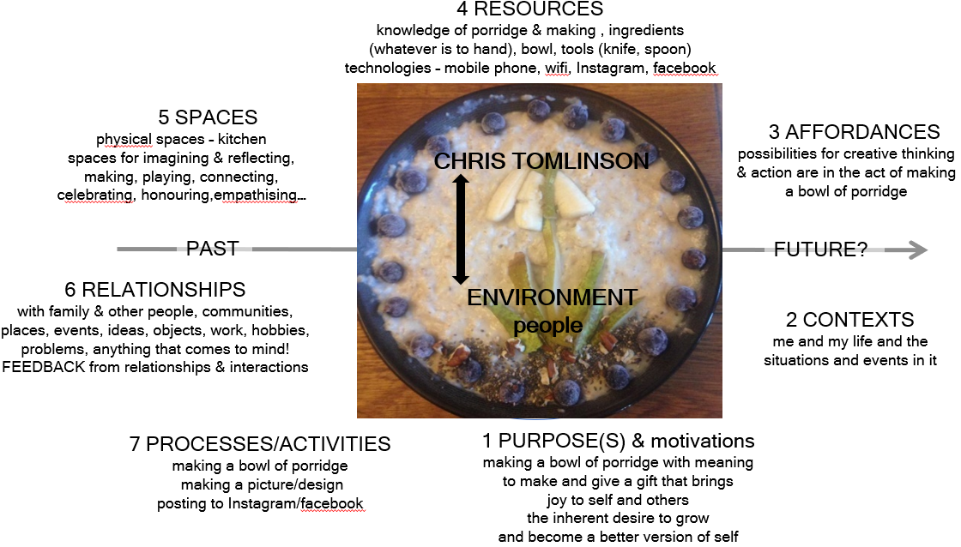
In her new book ‘Fostering Imagination in Higher Education’.⁷ Joy Whitton draws on the philosophical work of Paul Ricoeur¹⁰ to distinguish between reproductive and productive imagination.

“Ricoeur draws a distinction between ‘reproductive’ imagination, which relies on memory
and mimesis, and ‘productive’ imagination, which is generative. He asserts there are two main types of ‘reproductive’ imagination: the first refers to the way we bring common objects or experiences to the ‘mind’s eye’ in the form of an image…The second refers to material representations whose function is to somehow copy or ‘take the place of’ the things they represent (e.g., photographs, portraits, drawings, diagrams, and maps).”^{7 citing 8}

I invited her to comment on how Chris’ porridge making might be interpreted through Ricoeur:
I think in Ricoeur's terms the 'reproductive' imagination borrows from memory in reproducing the gift of love which nourishes the soul. But (and I'm thinking aloud here) maybe it's productive (imagination) in that porridge is the material symbol of that relation to mothering work, but a pale fictional version - it took time and attention to detail to make his beautiful porridge but the performance plays with, and is under no illusion that, it imperfectly represents that gift. The image of the porridge schematises well I think! - the relations between the gift giver, the gift recipient, and what is given.
Award winning photographer Dewitt Jones talks about personal creativity as ‘seeing the extraordinary in the ordinary’ and Chris’ story seems to be an excellent example of seeing the possibilities in a humble bowl of porridge and everyday life to use his creativity to create a gift that honours and celebrates the important people, relationships, incidents and events in his life, and share his gift with the world.

Acknowledgement
I am very grateful to Chris Tomlinson for sharing his story and his creativity, and to Joy Whitton, Jenny Willis and Chrissi Nerantzi for their observations and comments on the video of Chris making his porridge.

Sources
1 Chris Tomlinson ‘Day without porridge’ Instagram page
https://www.instagram.com/adaywithoutporridge/?hl=en
2 Making Porridge with Meaning
https://www.youtube.com/watch?v=ytFtrgZT9qU
3 Ingold, T. (2013) Making: Anthropology, archaeology, art and architecture p20-22
4 Gauntlet, D. (2011) Making is Connecting, The social meaning of creativity, from DIY and knitting to YouTube and Web 2.0. Cambridge: Polity Press, 2011, 232 pages
5 Rogers, C.R., (1960) On becoming a person. Boston: Houghton Mifflin
6 Jackson, N. J. (2016) Exploring Learning Ecologies
7 Whitton J (2018) Fostering Imagination in Higher Education Routledge
8 Ricoeur, P. (1984/85) Time and Narrative. 3 vols. trans. Kathleen McLaughlin and David Pellauer. Chicago: University of Chicago Press,

